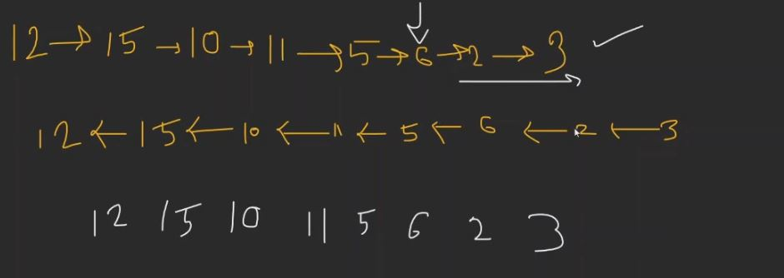

15 11 6 3 is ans.

Here the ques mean that in brute force we must check if for that node any node to the right greater than current node.

So, to check it out.

Brute.

**Method 1 (Simple)**   
Use two loops. In the outer loop, pick nodes of the linked list one by one. In the inner loop, check if there exists a node whose value is greater than the picked node. If there exists a node whose value is greater, then delete the picked node.   
**Time Complexity:** O(n^2)

Now for O(n)

Use reverse and take max number in variable max; whoever more than max include in Ans and if not delete it. also last element of array always included in ans.